**Service Provider System**

1)In service provider system publish the service….

a)create java project in java perspective by follwing screens hots

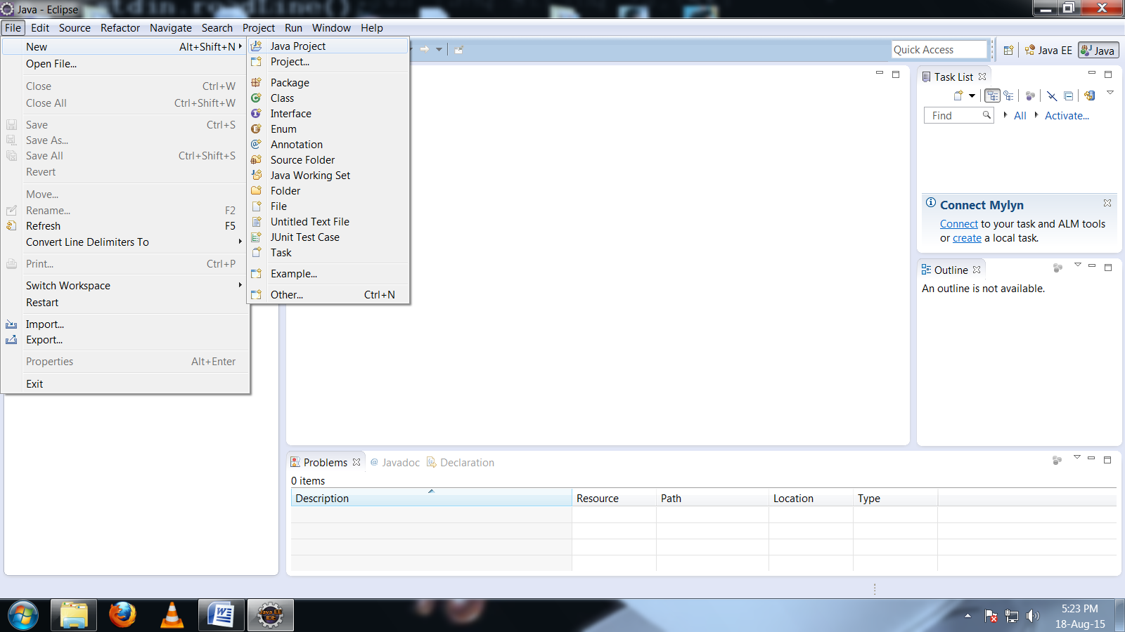

Project Name Service_Provider Click Finish

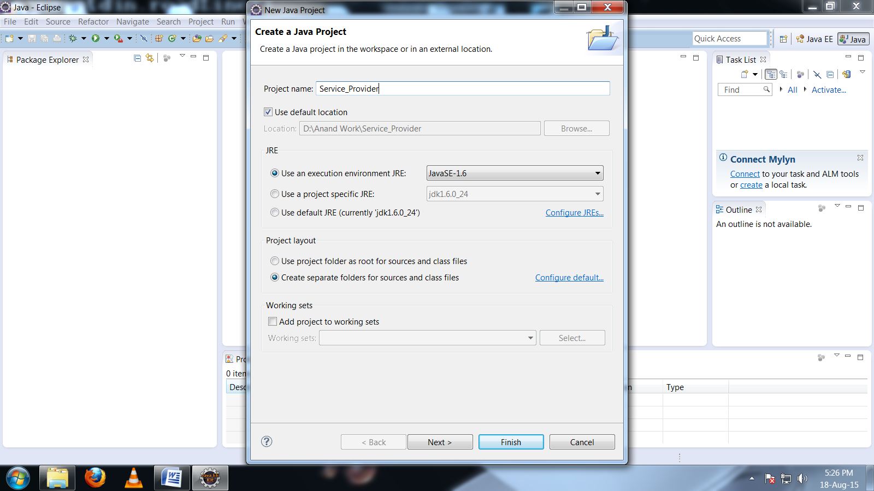

Right Click on src and create class

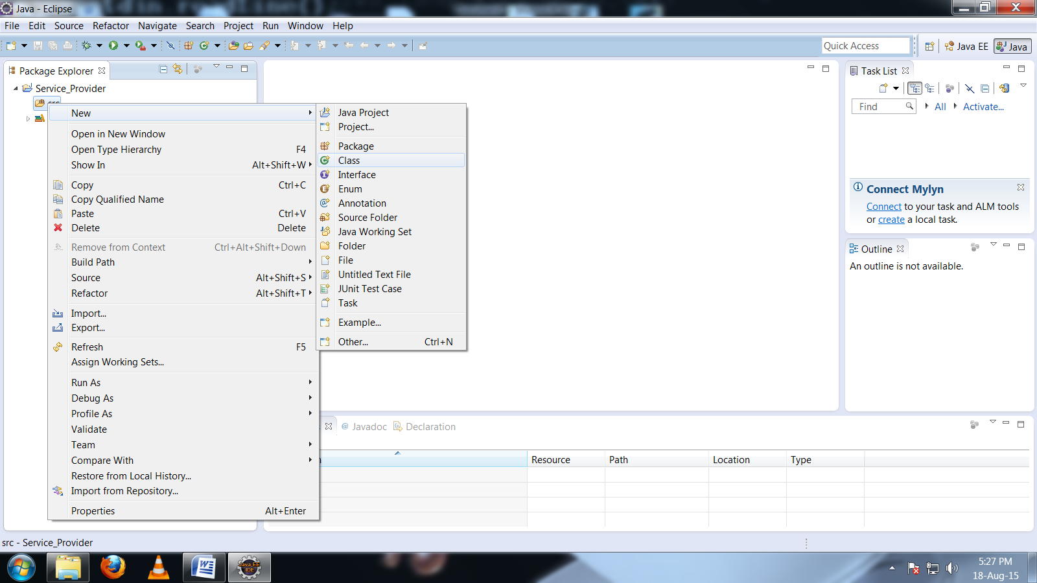

com.example.service==🡺package name

Calculations.java=====🡺Service Class Name

Click on Finish

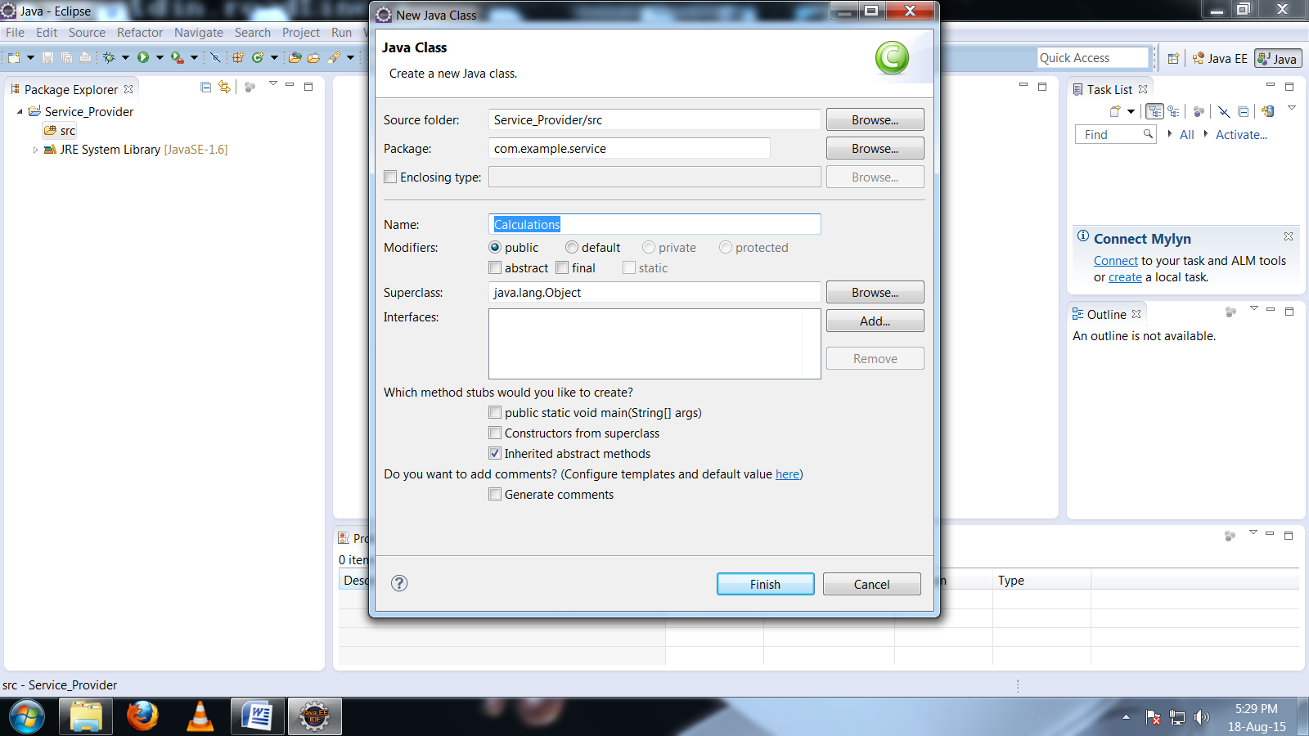

Now By using @WebMethod and @WebService annotations write the service program

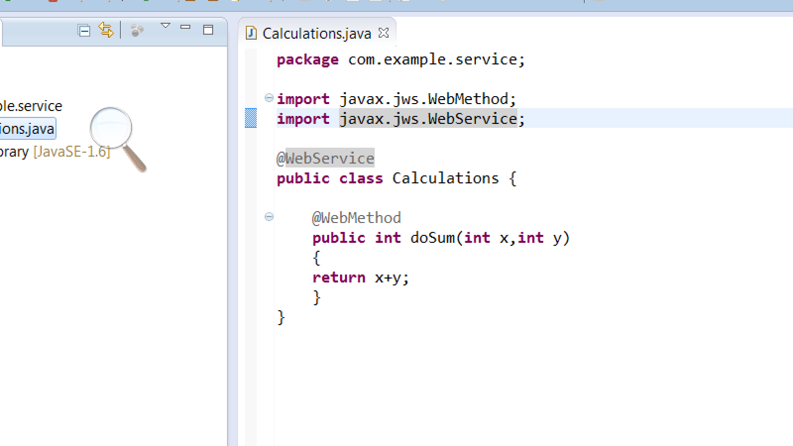

Now create another class to publish the service class

Publish_Service===🡺Class Name

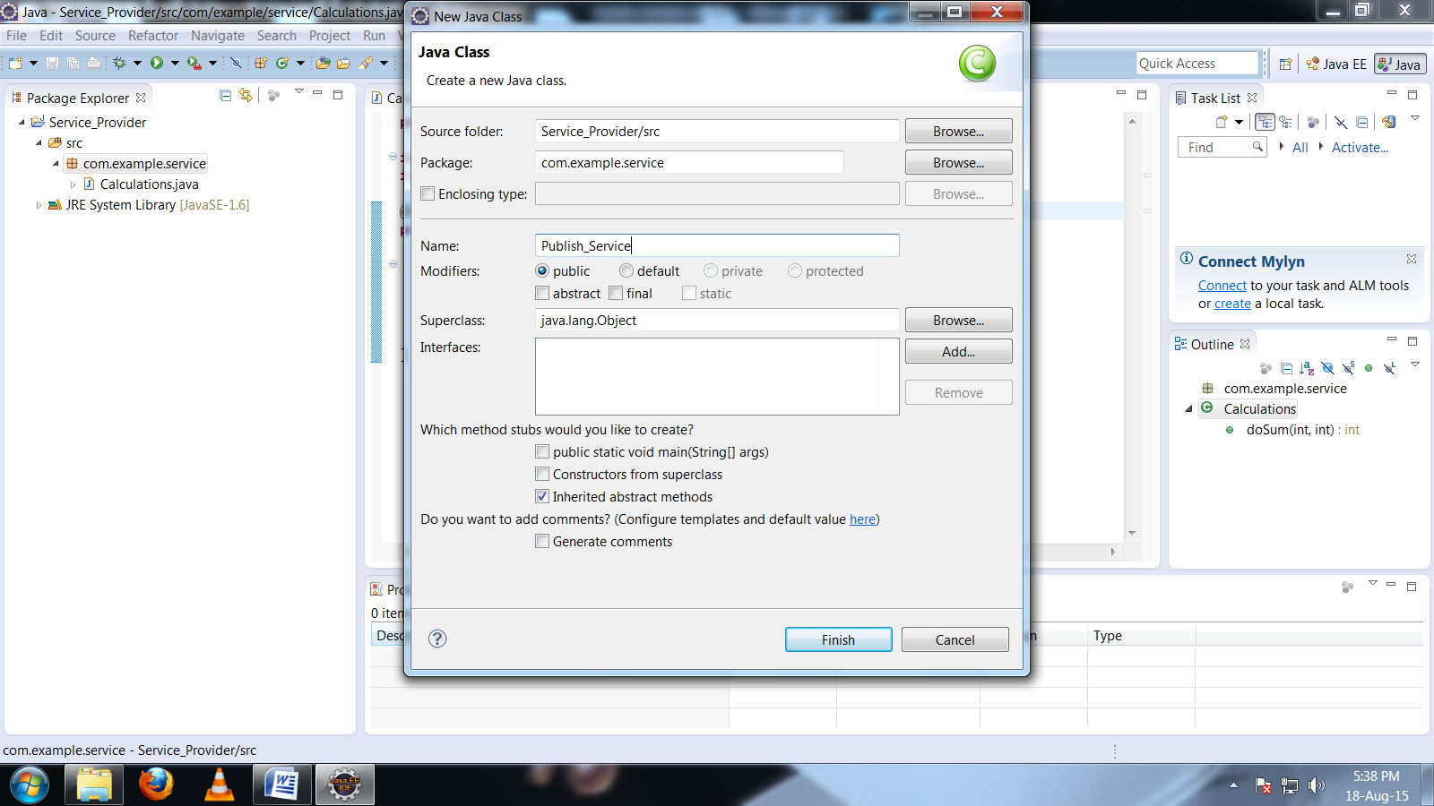

Now check your ipaddress to publish don’t use “localhost” open command prompt and type “ipconfig”

To know your ip address

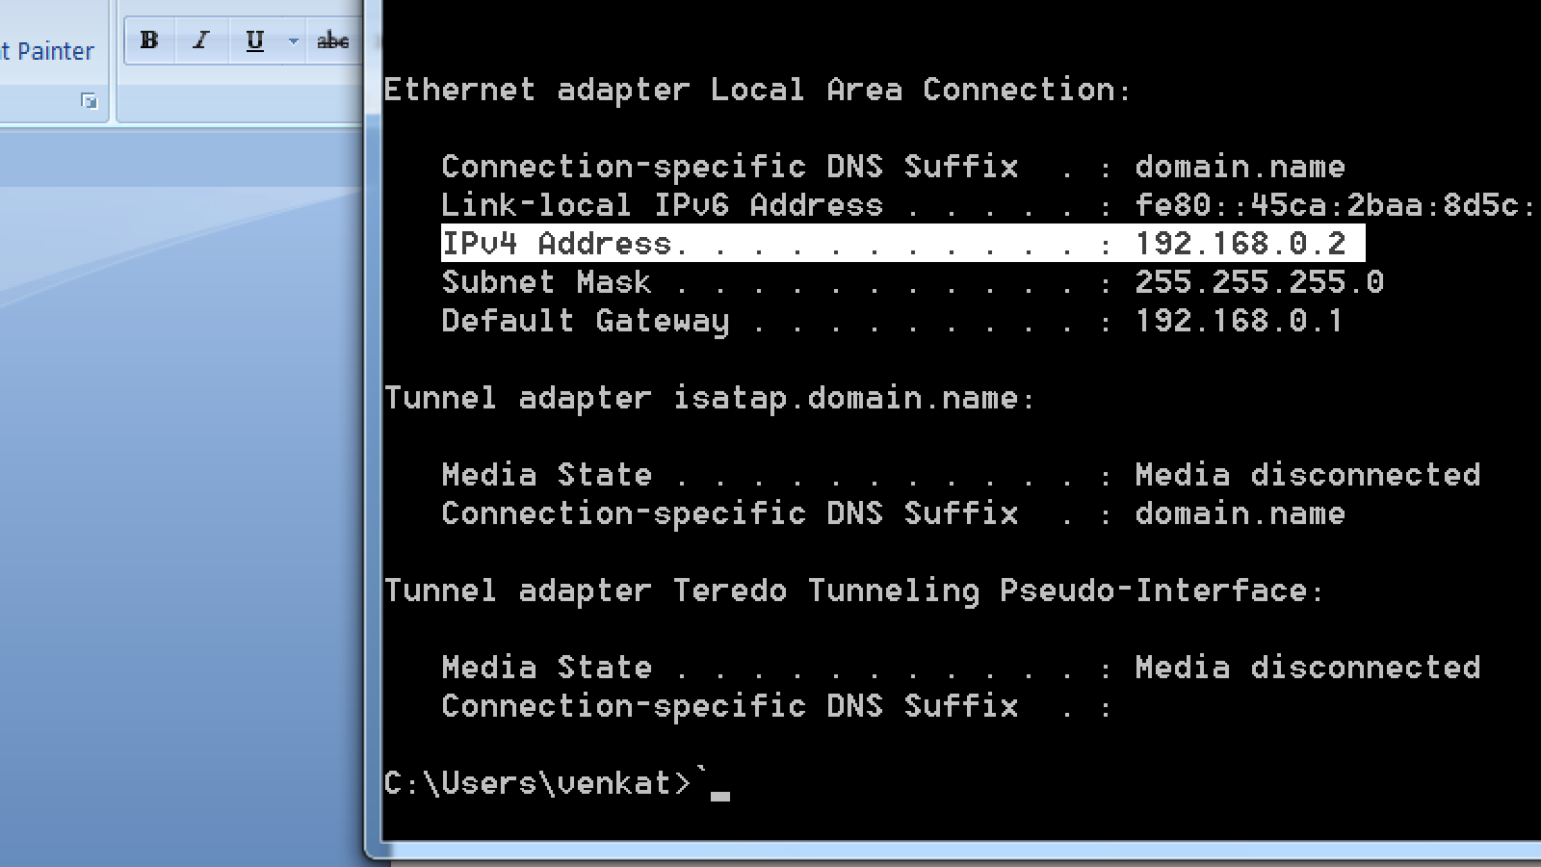

Now publish using “192.168.0.2” instead of using ” localhost”

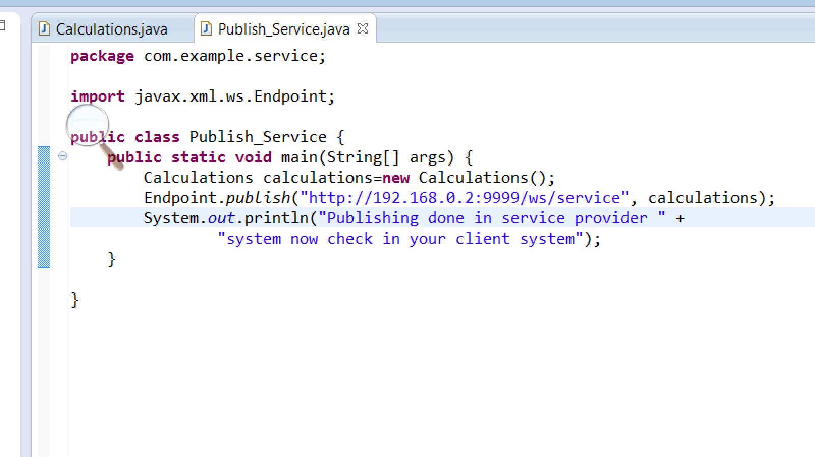

Now run the program to publish

Successfully published

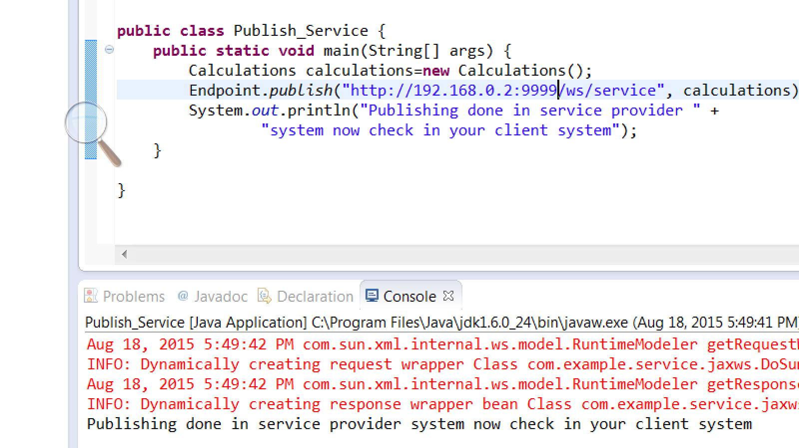

Now this is another system(Service Consumer)

Ipaddress is 192.168.0.4

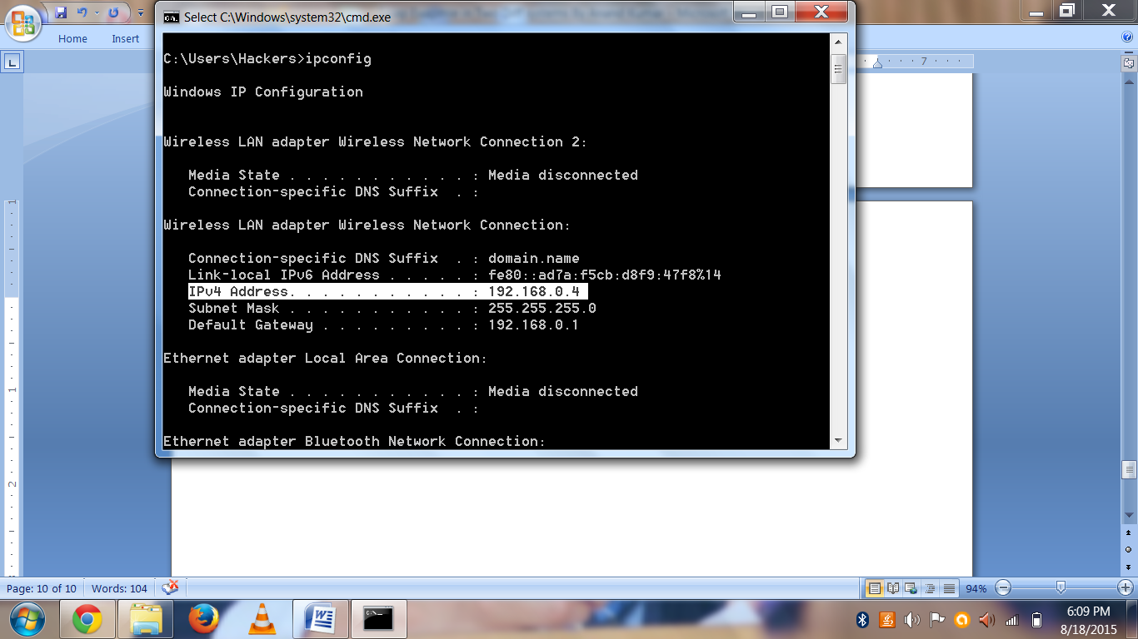

Now open browser to check whether wsdl file is available or not

Type <http://192.168.0.2:9999/ws/service?wsdl>

Get this wsdl file in this system

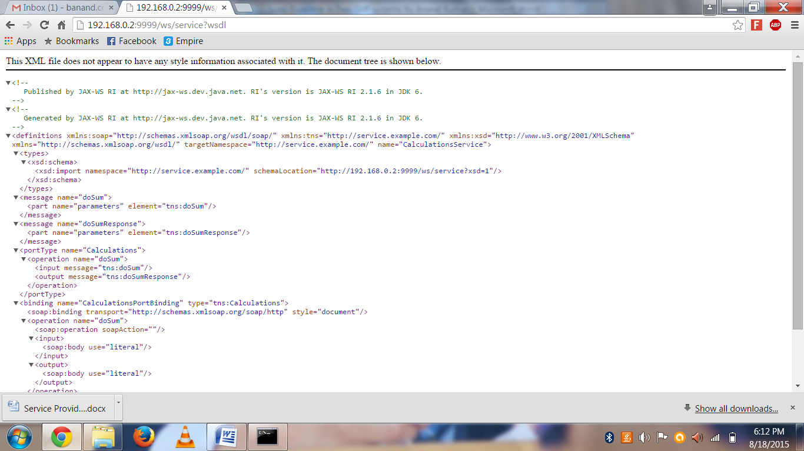

Now open eclipse in this system to access the provider system services…….

Create a project in Javaee perspective

Service_Consumer=======🡺project Name and also add server I am adding Tomcat7.0

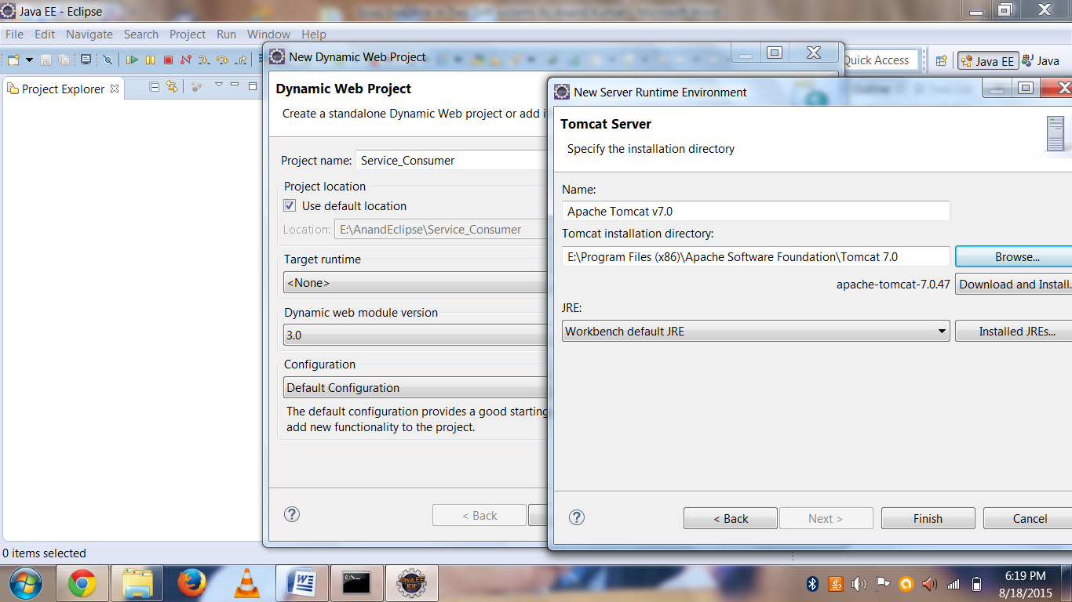

Now generate the stubs

i)get the path to generate the stubs right click on “src=🡺properties”

Location is: E:\AnandEclipse\Service_Consumer\src

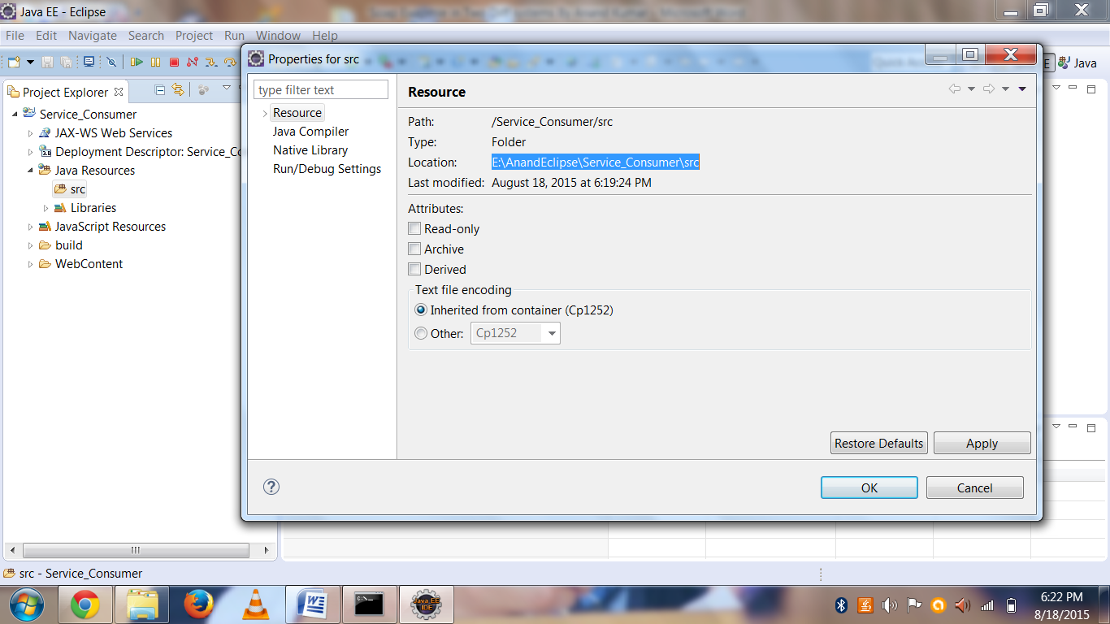

Now open command prompt to generate the stubs

Thank god I got stubs in consumer system with out errors

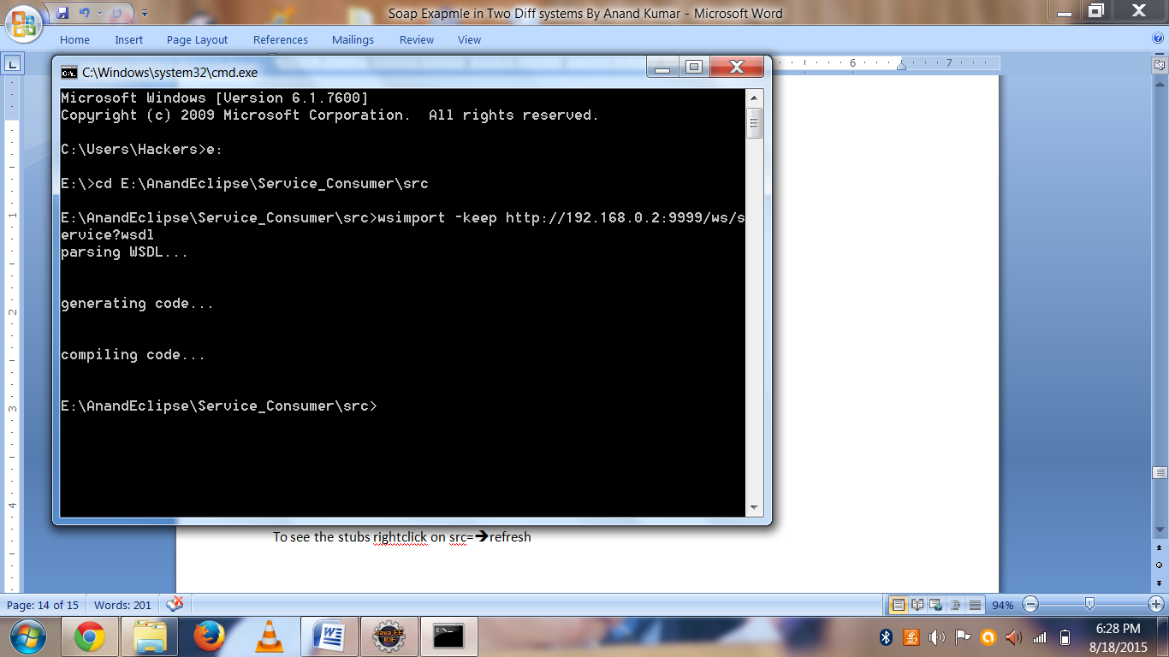

To see the stubs rightclick on src=🡺refresh

Stubs are generated

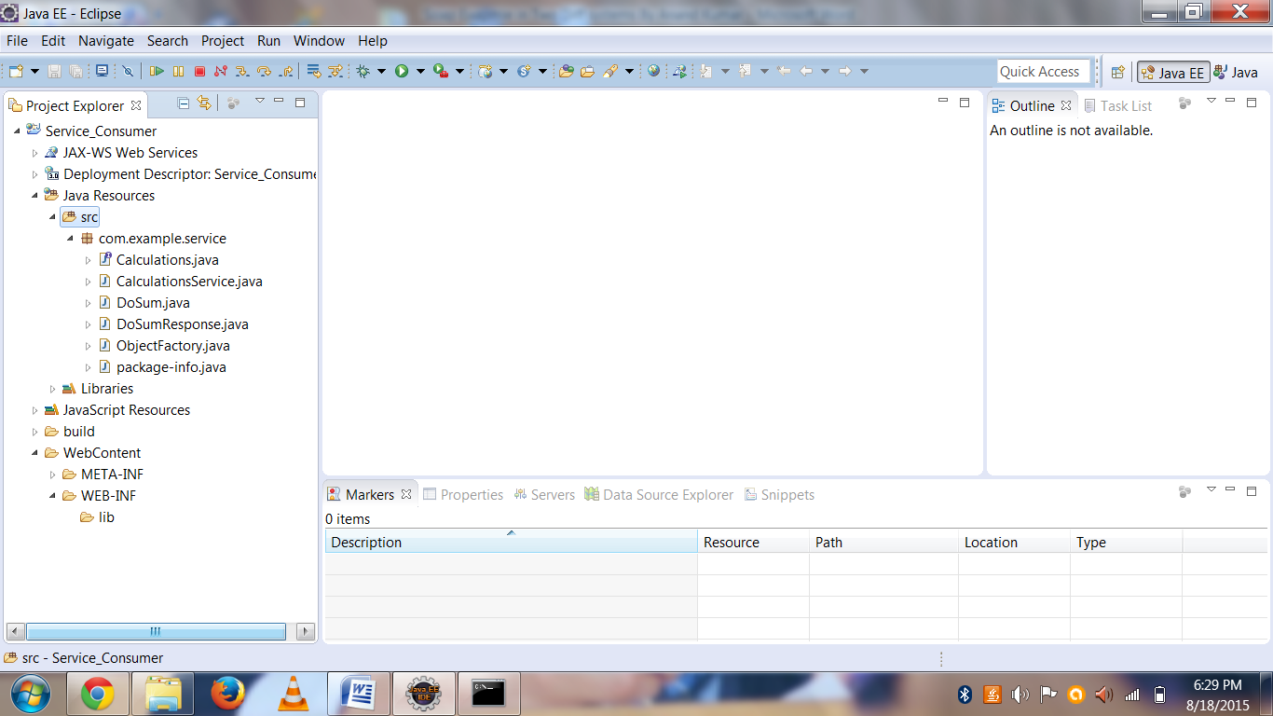

Now create a jsp page for giving input

Right click on webcontent=🡺new==🡺jspfile

Give Jsp Name as “index.jsp”

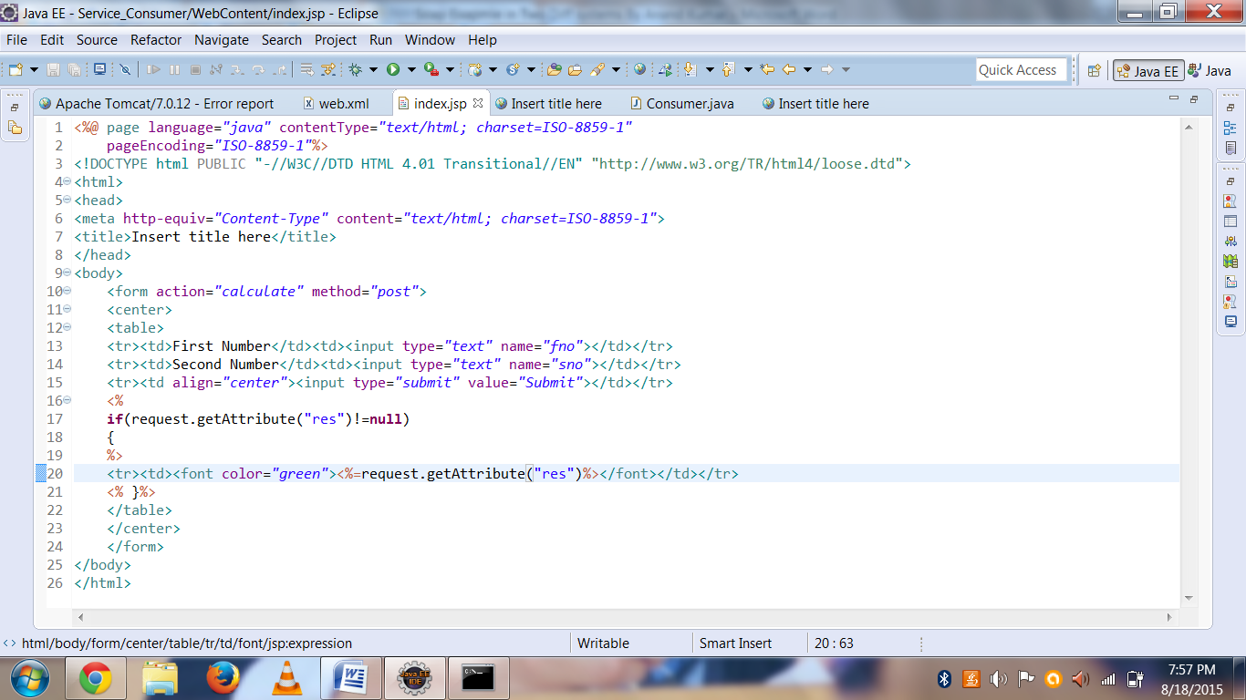

Now create a servlet name is Consumer and url pattern is calculate

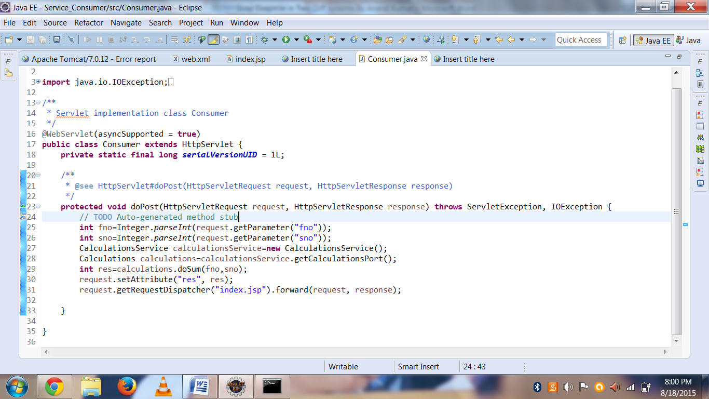

Now run the project

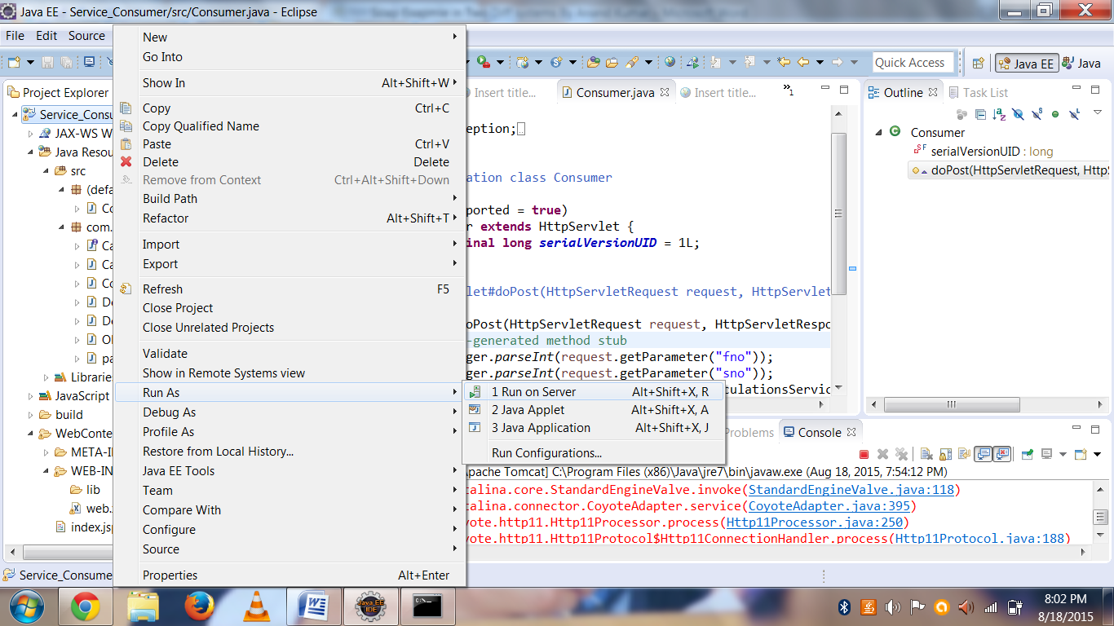

You get this screen Copy this url and paste on browser

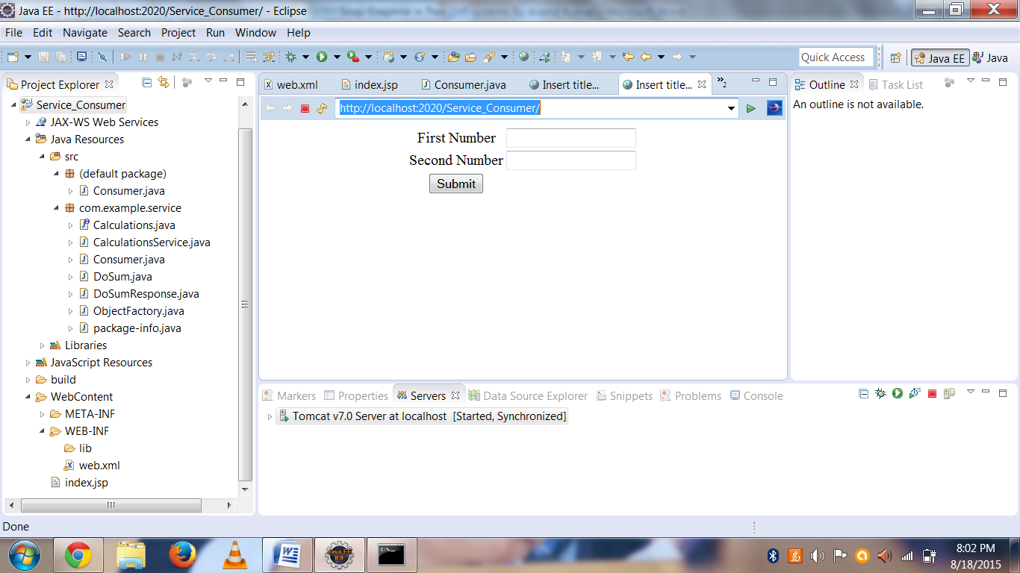

Now paste in the browser you will get page like this

<http://localhost:2020/Service_Consumer/>

now test in your own by giving input values

